**Task- 1**

**Aim: Create an app as shown in below image.**

**Program:**

import 'package:flutter/material.dart';

void main() {

runApp(

const MaterialApp(

debugShowCheckedModeBanner: false,

home: Calc(),

),

);

}

class Calc extends StatefulWidget {

const Calc({Key? key}) : super(key: key);

@override

State<Calc> createState() => _CalcState();

}

class _CalcState extends State<Calc> {

int _boxVal = 0;

@override

Widget build(BuildContext context) {

return Scaffold(

appBar: AppBar(

title: const Text("Calc"),

centerTitle: true,

backgroundColor: const Color(0xff546e8f),

),

body: Align(

alignment: Alignment.center,

child: Column(

mainAxisAlignment: MainAxisAlignment.center,

children: [

Text(

'$_boxVal',

style: const TextStyle(

color: Colors.black54,

fontSize: 75,

),

),

const SizedBox(height: 50),

Row(

mainAxisAlignment: MainAxisAlignment.spaceAround,

children: [

Box('-2'),

const SizedBox(height: 90),

Box('+2'),

],

),

Row(

mainAxisAlignment: MainAxisAlignment.spaceAround,

children: [

Box('-4'),

const SizedBox(height: 90),

Box('+4'),

],

),

const SizedBox(height: 30),

Box('Clear'),

],

),

),

);

}

Widget Box(num) {

return InkWell(

onTap: () {

if (num == '-2') {

_boxVal = _boxVal - 2;

} else if (num == '+2') {

_boxVal = _boxVal + 2;

} else if (num == '-4') {

_boxVal = _boxVal - 4;

} else if (num == '+4') {

_boxVal = _boxVal + 4;

} else if (num == 'Clear') {

_boxVal = 0;

}

setState(() {

_boxVal;

});

},

child: Container(

width: 160,

height: 60,

decoration: BoxDecoration(

color: const Color(0xff546e8f),

borderRadius: BorderRadius.circular(10),

),

alignment: Alignment.center,

child: Text(

num,

style: const TextStyle(

color: Colors.white,

fontSize: 30,

),

),

),

);

}

}

**Output:**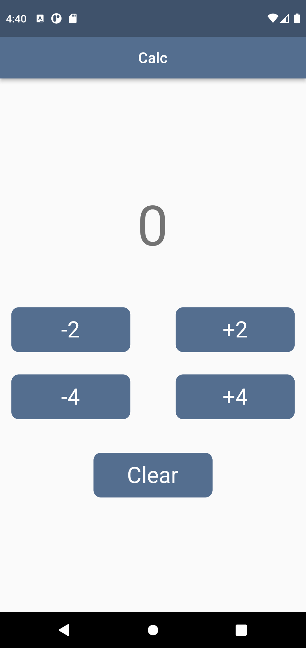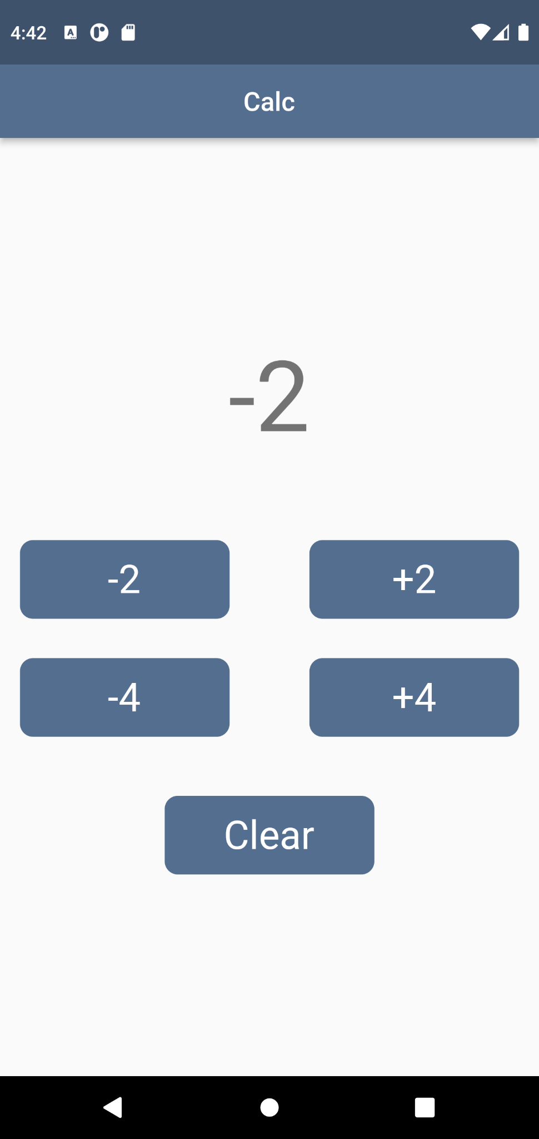

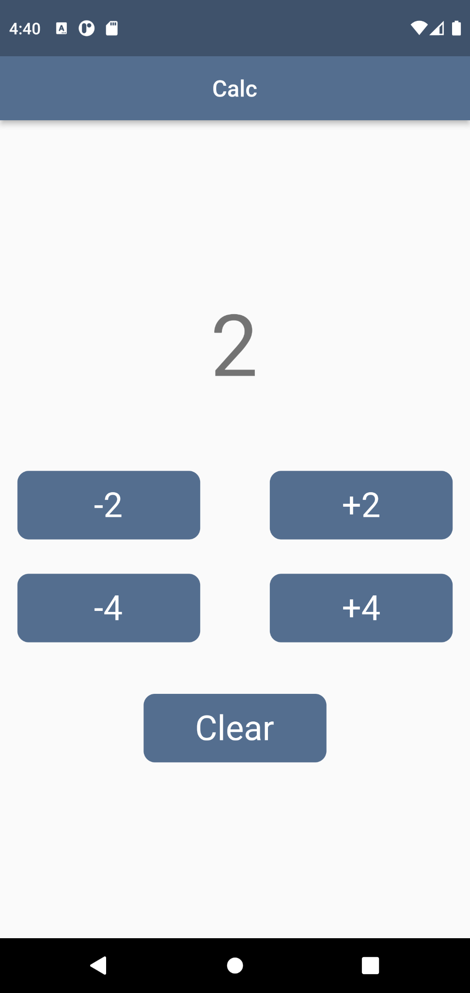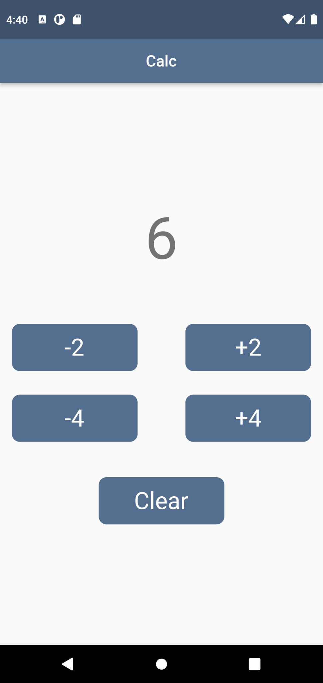

**Task- 2**

**Aim: Create an app as shown in below image.**

**Program:**

import 'package:flutter/material.dart';

void main() {

runApp(

const MaterialApp(

debugShowCheckedModeBanner: false,

home: Map(),

),

);

}

class Map extends StatefulWidget {

const Map({Key? key}) : super(key: key);

@override

State<Map> createState() => _MapState();

}

class _MapState extends State<Map> {

List Icons_Name = <String>[

"Exit",

"Play",

"Pause",

"Stop",

"Close",

"Delete",

"Email",

];

List Icons2 = const <IconData>[

Icons.exit_to_app,

Icons.play_arrow_sharp,

Icons.pause,

Icons.stop,

Icons.close,

Icons.delete,

Icons.email,

];

@override

Widget build(BuildContext context) {

return Scaffold(

appBar: AppBar(

title: const Text(

"Map",

style: TextStyle(

fontSize: 22,

),

),

centerTitle: true,

leading: const Icon(Icons.menu),

),

body: Container(

color: const Color(0xffeeeeee).withOpacity(0.2),

child: SingleChildScrollView(

scrollDirection: Axis.vertical,

child: Row(

children: [

Expanded(

child: Column(

mainAxisAlignment: MainAxisAlignment.start,

children: Icons_Name.map((e) {

return Column(

children: [

Container(

margin: const EdgeInsets.only(top: 7, bottom: 7),

alignment: Alignment.centerLeft,

color: Colors.white,

height: 90,

child: Container(

margin: const EdgeInsets.only(left: 10),

child: Text(

e,

style: const TextStyle(

fontSize: 20,

),

),

),

),

],

);

}).toList()),

),

Expanded(

child: Column(

mainAxisAlignment: MainAxisAlignment.end,

children: Icons2.map(

(icons) {

return Column(

children: [

Container(

margin: const EdgeInsets.only(top: 7, bottom: 7),

alignment: Alignment.centerLeft,

color: Colors.white,

height: 90,

child: Container(

margin: const EdgeInsets.only(left: 140),

child: Icon(

icons,

size: 25,

),

),

),

],

);

},

).toList()),

),

],

),

),

),

);

}

}

**Output:**

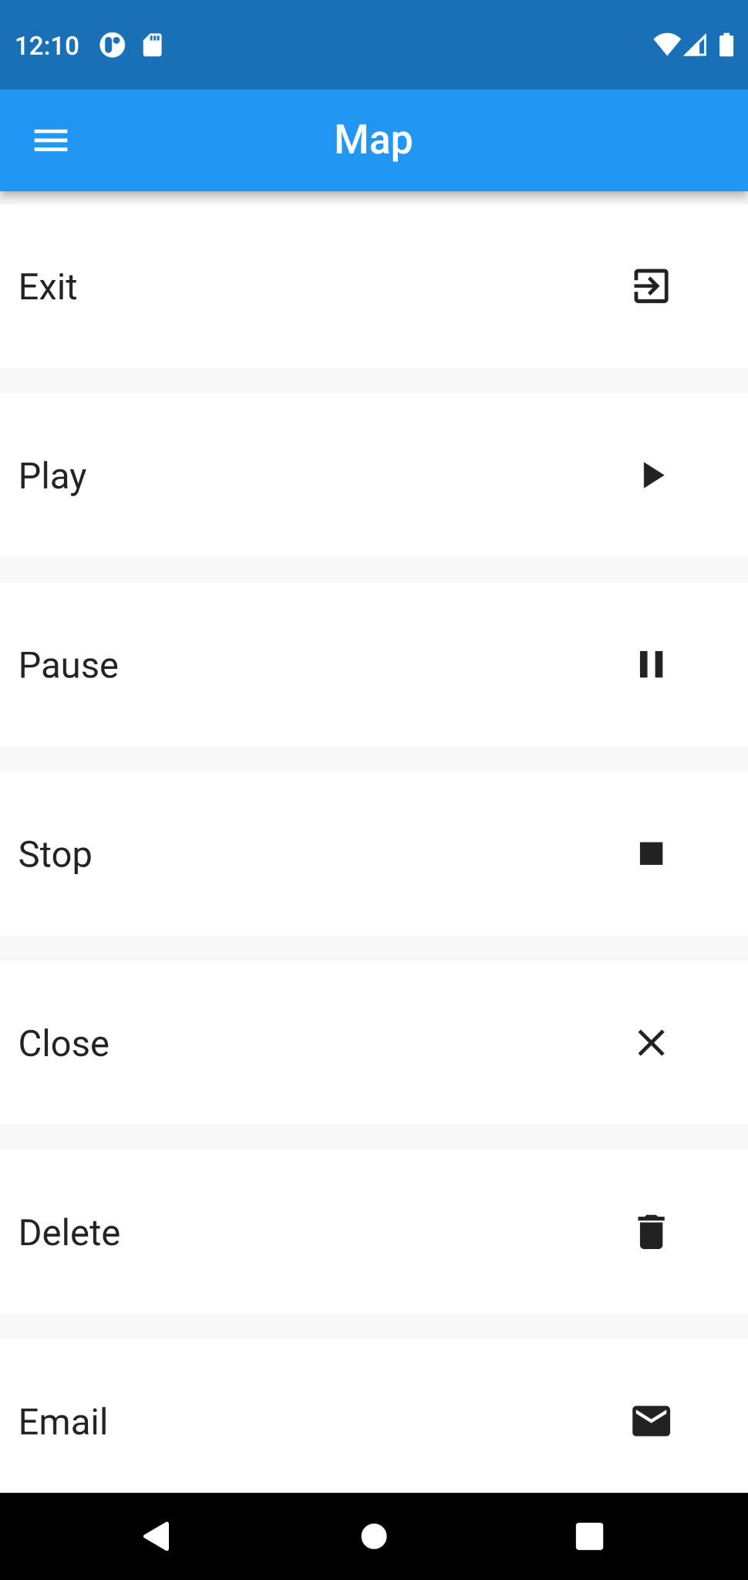

**Task- 3**

**Aim: Create an app as shown in below image.**

**Program:**

import 'package:flutter/material.dart';

void main() {

runApp(

const MaterialApp(

debugShowCheckedModeBanner: false,

home: iconsMenu(),

),

);

}

class iconsMenu extends StatefulWidget {

const iconsMenu({Key? key}) : super(key: key);

@override

State<iconsMenu> createState() => _iconsMenuState();

}

class _iconsMenuState extends State<iconsMenu> {

var myIcon = [

Icons.add,

Icons.album_rounded,

Icons.arrow_back_ios,

Icons.arrow_forward_ios,

Icons.access_alarm_outlined,

];

var myIcon2 = [

Icons.shield,

Icons.account_circle_outlined,

Icons.autorenew_rounded,

Icons.shuffle,

];

var myIcon3 = [

Icons.more_rounded,

Icons.more_vert,

Icons.arrow_downward_rounded,

];

var myIcon4 = [

Icons.call,

Icons.search,

Icons.report_problem_outlined,

Icons.stop,

Icons.play_arrow,

];

var myIcon5 = [

Icons.view_module,

Icons.spoke_outlined,

Icons.wifi_lock,

];

@override

Widget build(BuildContext context) {

return Scaffold(

backgroundColor: Colors.white,

appBar: AppBar(

backgroundColor: Colors.white,

title: const Text(

"Icons",

style: TextStyle(color: Colors.black),

),

centerTitle: true,

),

body: Column(

children: [

SingleChildScrollView(

scrollDirection: Axis.horizontal,

child: Row(

children: [

Container(

margin: EdgeInsets.only(left: 15),

height: 140,

child: SingleChildScrollView(

scrollDirection: Axis.horizontal,

child: Row(

children: myIcon.map((e) {

return Row(

children: [

Container(

margin: const EdgeInsets.only(

top: 7,

left: 10,

),

height: 120,

width: 120,

child: Icon(

e,

size: 27,

),

decoration: BoxDecoration(

color: Color(0XFFf5f5f5),

borderRadius: BorderRadius.circular(10),

boxShadow: const <BoxShadow>[

BoxShadow(

color: Colors.black12,

offset: Offset(0, 10),

blurRadius: 5,

),

]),

),

const SizedBox(width: 20),

],

);

}).toList(),

),

),

),

],

),

),

Container(

margin: EdgeInsets.only(left: 15),

height: 140,

child: SingleChildScrollView(

scrollDirection: Axis.horizontal,

child: Row(

children: myIcon2.map((i) {

return Row(

children: [

Container(

margin: const EdgeInsets.only(

top: 7,

left: 10,

),

height: 120,

width: 120,

child: Icon(

i,

size: 27,

),

decoration: BoxDecoration(

color: Color(0XFFf5f5f5),

borderRadius: BorderRadius.circular(10),

boxShadow: const <BoxShadow>[

BoxShadow(

color: Colors.black12,

offset: Offset(0, 10),

blurRadius: 5,

),

]),

),

const SizedBox(width: 20),

],

);

}).toList(),

),

),

),

Container(

margin: EdgeInsets.only(left: 15),

height: 140,

child: SingleChildScrollView(

scrollDirection: Axis.horizontal,

child: Row(

children: myIcon3.map((i) {

return Row(

children: [

Container(

margin: const EdgeInsets.only(

top: 7,

left: 10,

),

height: 120,

width: 120,

child: Icon(

i,

size: 27,

),

decoration: BoxDecoration(

color: Color(0XFFf5f5f5),

borderRadius: BorderRadius.circular(10),

boxShadow: const <BoxShadow>[

BoxShadow(

color: Colors.black12,

offset: Offset(0, 10),

blurRadius: 5,

),

]),

),

const SizedBox(width: 20),

],

);

}).toList(),

),

),

),

Container(

margin: EdgeInsets.only(left: 15),

height: 140,

child: SingleChildScrollView(

scrollDirection: Axis.horizontal,

child: Row(

children: myIcon4.map((i) {

return Row(

children: [

Container(

margin: const EdgeInsets.only(

top: 7,

left: 10,

),

height: 120,

width: 120,

child: Icon(

i,

size: 27,

),

decoration: BoxDecoration(

color: Color(0XFFf5f5f5),

borderRadius: BorderRadius.circular(10),

boxShadow: const <BoxShadow>[

BoxShadow(

color: Colors.black12,

offset: Offset(0, 10),

blurRadius: 5,

),

],

),

),

const SizedBox(width: 20),

],

);

}).toList(),

),

),

),

Container(

margin: EdgeInsets.only(left: 15),

height: 140,

child: SingleChildScrollView(

scrollDirection: Axis.horizontal,

child: Row(

children: myIcon5.map(

(i) {

return Row(

children: [

Container(

margin: const EdgeInsets.only(

top: 7,

left: 10,

),

height: 120,

width: 120,

child: Icon(

i,

size: 27,

),

decoration: BoxDecoration(

color: Color(0XFFf5f5f5),

borderRadius: BorderRadius.circular(10),

boxShadow: const <BoxShadow>[

BoxShadow(

color: Colors.black12,

offset: Offset(0, 10),

blurRadius: 5,

),

],

),

),

const SizedBox(width: 20),

],

);

},

).toList(),

),

),

),

],

),

);

}

}

**Output:**

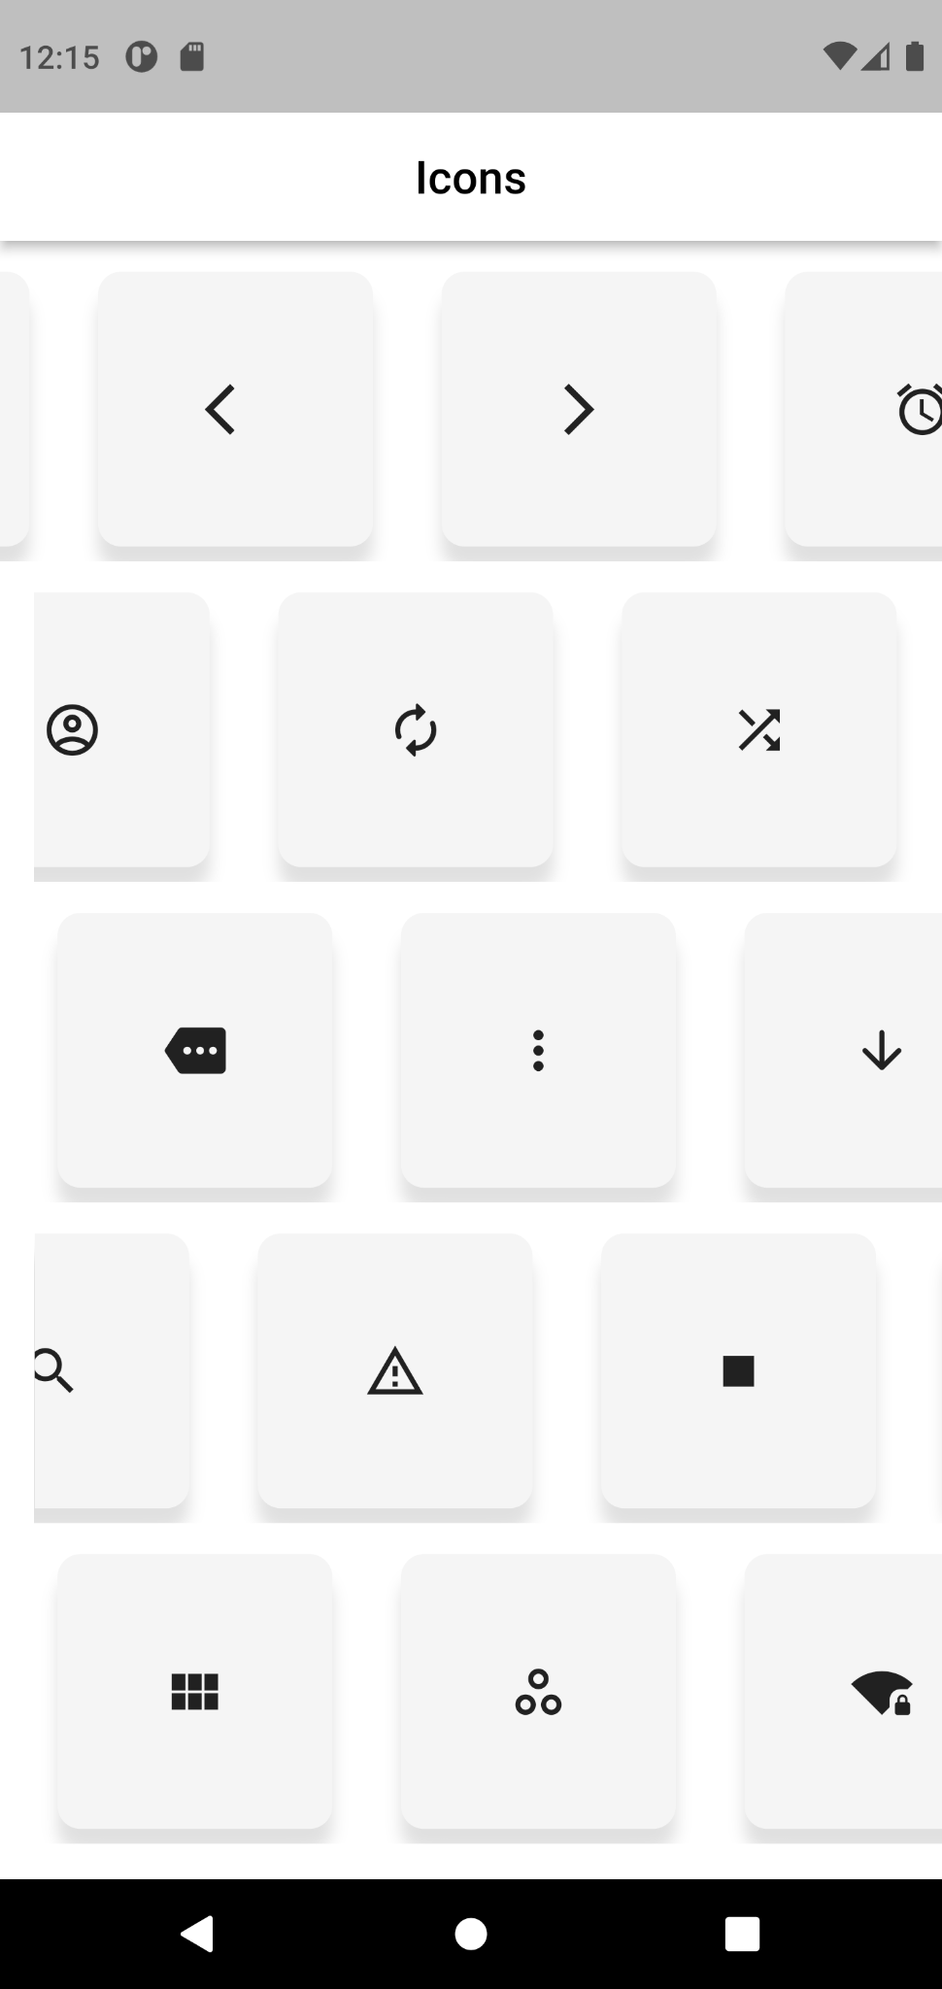

**Task- 4**

**Aim: Create an app as shown in below image.**

**Program:**

import 'package:flutter/material.dart';

void main() {

runApp(

const MaterialApp(

debugShowCheckedModeBanner: false,

home: dynamicList(),

),

);

}

class dynamicList extends StatefulWidget {

const dynamicList({Key? key}) : super(key: key);

@override

State<dynamicList> createState() => _dynamicListState();

}

class _dynamicListState extends State<dynamicList> {

int s = 10;

var numb = [1, 2, 3, 4, 5, 6, 7, 8, 9, 10];

var mydecor = BoxDecoration(

color: Color(0XFF75e2ff),

borderRadius: BorderRadius.circular(10),

);

var mydecor2 = BoxDecoration(

color: Color(0XFF5689c0),

borderRadius: BorderRadius.circular(10),

);

@override

Widget build(BuildContext context) {

return Scaffold(

appBar: AppBar(

title: Text("Dynamic List"),

centerTitle: true,

backgroundColor: Color(0XFF244d61),

),

body: SingleChildScrollView(

child: Column(

children: numb.map(

(e) {

return Container(

margin: EdgeInsets.only(top: 5, bottom: 6),

height: 100,

width: double.infinity,

alignment: Alignment.center,

child: Text(

"$e",

style: const TextStyle(

color: Colors.white,

fontSize: 40,

),

),

decoration: BoxDecoration(

color: (e % 2 == 1) ? Color(0XFF75e2ff) : Color(0XFF5689c0),

borderRadius: BorderRadius.circular(10),

),

);

},

).toList(),

),

),

floatingActionButton: Row(

mainAxisAlignment: MainAxisAlignment.end,

children: [

InkWell(

onTap: () {

setState(() {

s = s + 1;

numb.add(s);

});

},

child: Ink(

child: Container(

height: 60,

width: 60,

child: const Icon(

Icons.add,

color: Colors.white,

size: 30,

),

decoration: const BoxDecoration(

shape: BoxShape.circle,

color: Colors.blue,

),

),

),

),

const SizedBox(width: 10),

InkWell(

onTap: () {

setState(() {

numb.remove(s);

(s > 0) ? s = s - 1 : s = 0;

});

},

child: Ink(

child: Container(

height: 60,

width: 60,

child: const Icon(

Icons.remove,

color: Colors.white,

size: 30,

),

decoration: const BoxDecoration(

shape: BoxShape.circle,

color: Colors.blue,

),

),

),

),

],

),

);

}

}

**Output:**

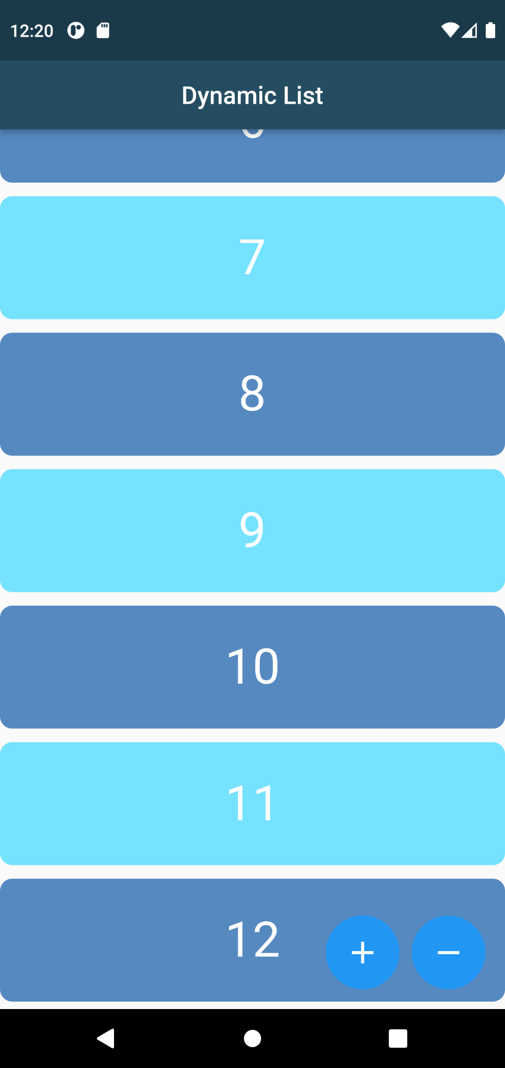

**Task- 5**

**Aim: Create an app as shown in below image.**

**Program:**

import 'package:flutter/material.dart';

void main() {

runApp(

const MaterialApp(

debugShowCheckedModeBanner: false,

home: iconEditor(),

),

);

}

class iconEditor extends StatefulWidget {

const iconEditor({Key? key}) : super(key: key);

@override

State<iconEditor> createState() => _iconEditorState();

}

class _iconEditorState extends State<iconEditor> {

var mydecor = BoxDecoration(

color: Colors.white,

borderRadius: BorderRadius.circular(10),

boxShadow: const <BoxShadow>[

BoxShadow(

color: Colors.black12,

spreadRadius: 5,

blurRadius: 15,

),

]);

var mycolor = [

Colors.blue,

Colors.orange,

Colors.red,

Colors.purple,

Colors.deepPurpleAccent,

Colors.yellow,

Colors.black,

Colors.green,

];

var newIcon = Icons.arrow_back_ios;

var newColor = Colors.black;

var myIcon = [

Icons.add,

Icons.album,

Icons.arrow_back_ios_outlined,

Icons.arrow_forward_ios,

Icons.alarm,

Icons.call,

Icons.search,

];

@override

Widget build(BuildContext context) {

return Scaffold(

backgroundColor: Colors.grey,

appBar: AppBar(

backgroundColor: Colors.white,

title: const Text(

"Icons Editor",

style: TextStyle(color: Colors.black, fontSize: 19),

),

centerTitle: true,

),

body: Column(

children: [

Container(

margin: EdgeInsets.only(top: 10, left: 11, right: 10),

height: 260,

width: 490,

child: const Icon(

Icons.arrow_back_ios_outlined,

size: 70,

),

decoration: mydecor,

),

Container(

margin: EdgeInsets.only(top: 10, left: 11, right: 10),

height: 50,

width: 490,

child: const Center(

child: Text(

"Select Color",

style: TextStyle(fontSize: 15),

),

),

decoration: mydecor,

),

Container(

margin: EdgeInsets.only(top: 10, left: 11, right: 10),

height: 110,

width: 490,

decoration: mydecor,

child: SingleChildScrollView(

scrollDirection: Axis.horizontal,

child: Row(

children: mycolor.map((e) {

return InkWell(

onTap: () {

setState(() {

newColor = e;

});

},

child: Ink(

child: Container(

margin: EdgeInsets.only(left: 7, right: 7),

width: 100,

height: 95,

decoration: BoxDecoration(

color: e,

borderRadius: BorderRadius.circular(10),

),

),

),

);

}).toList(),

),

),

),

Container(

margin: EdgeInsets.only(top: 10, left: 11, right: 10),

height: 55,

width: 490,

alignment: Alignment.center,

child: const Text(

"Select Icon",

style: TextStyle(fontSize: 15),

),

decoration: mydecor,

),

Container(

margin: EdgeInsets.only(top: 10, left: 11, right: 10),

height: 110,

width: 490,

decoration: mydecor,

child: SingleChildScrollView(

scrollDirection: Axis.horizontal,

child: Row(

children: myIcon.map((a) {

return InkWell(

onTap: () {

setState(() {

newIcon = a;

});

},

child: Ink(

child: Container(

margin: EdgeInsets.only(left: 7, right: 7),

width: 100,

height: 95,

child: Icon(

a,

color: newColor,

size: 40,

),

decoration: BoxDecoration(

color: Colors.white,

borderRadius: BorderRadius.circular(10),

boxShadow: const <BoxShadow>[

BoxShadow(

color: Colors.black12,

spreadRadius: 5,

blurRadius: 15,

),

],

),

),

),

);

}).toList(),

),

),

),

],

),

);

}

}

**Output:**

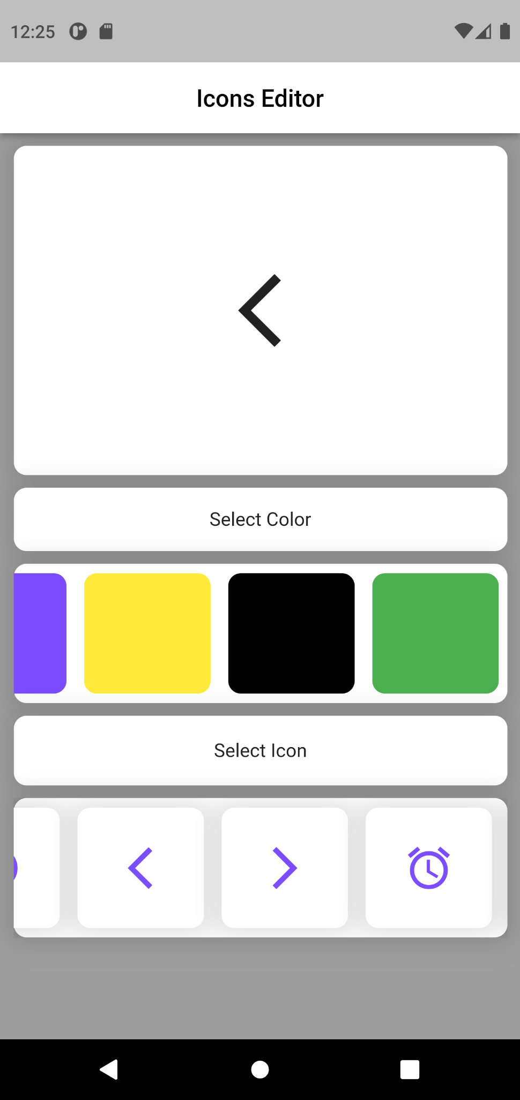

**Task- 5**